PHYSICS FORM THREE
CHAPTER ONE
LINEAR MOTION
Introduction
Study of motion is divided into two;
- Kinematics
- Dynamics
In kinematics forces causing motion are disregarded while dynamics deals with motion of objects and the forces causing them.
- Displacement
Distance moved by a body in a specified direction is called displacement. It is denoted by letter‘s’ and has both magnitude and direction. Distance is the movement from one point to another. The Si unit for displacement is the metre (m).
- Speed
This is the distance covered per unit time.
Speed= distance covered/ time taken. Distance is a scalar quantity since it has magnitude only. The SI unit for speed is metres per second (m/s or ms⁻¹)
Average speed= total distance covered/total time taken
Other units for speed used are Km/h.
Examples
- A body covers a distance of 10m in 4 seconds. It rests for 10 seconds and finally covers a distance of 90m in 60 seconds. Calculate the average speed.
Solution
Total distance covered=10+90=100m
Total time taken=4+10+6=20 seconds
Therefore average speed=100/20=5m/s
- Calculate the distance in metres covered by a body moving with a uniform speed of 180 km/h in 30 seconds.
Solution
Distance covered=speed*time
=180*1000/60*60=50m/s
=50*30
=1,500m
- Calculate the time in seconds taken a by body moving with a uniform speed of 360km/h to cover a distance of 3,000 km?
Solution
Speed: 360 km/h=360*1000/60*60=100m/s
Time=distance/speed
3000*1000/100
=30,000 seconds.
- Velocity
This is the change of displacement per unit time. It is a vector quantity.
Velocity=change in displacement/total time taken
The SI units for velocity are m/s
Examples
- A man runs 800m due North in 100 seconds, followed by 400m due South in 80 seconds. Calculate,
- His average speed
- His average velocity
- His change in velocity for the whole journey
Solution
- Average speed: total distance travelled/total time taken
=800+400/100+80
=1200/180
=6.67m/s
- Average velocity: total displacement/total time
=800-400/180
=400/180
=2.22 m/s due North
- Change in velocity=final-initial velocity
= (800/100)-(400-80)
=8-5
=3m/s due North
- A tennis ball hits a vertical wall at a velocity of 10m/s and bounces off at the same velocity. Determine the change in velocity.
Solution
Initial velocity (u) =-10m/s
Final velocity (v) = 10m/s
Therefore change in velocity= v-u
=10- (-10)
=20m/s
- Acceleration
This is the change of velocity per unit time. It is a vector quantity symbolized by ‘a’.
Acceleration ‘a’=change in velocity/time taken= v-u/t
The SI units for acceleration are m/s²
Examples
- The velocity of a body increases from 72 km/h to 144 km/h in 10 seconds. Calculate its acceleration.
Solution
Initial velocity= 72 km/h=20m/s
Final velocity= 144 km/h=40m/s
Therefore ‘a’ =v-u/t
= 40-20/10
2m/s²
- A car is brought to rest from 180km/h in 20 seconds. What is its retardation?
Solution
Initial velocity=180km/h=50m/s
Final velocity= 0 m/s
A = v-u/t=0-50/20
= -2.5 m/s²
Hence retardation is 2.5 m/s²

Motion graphs
Distance-time graphs

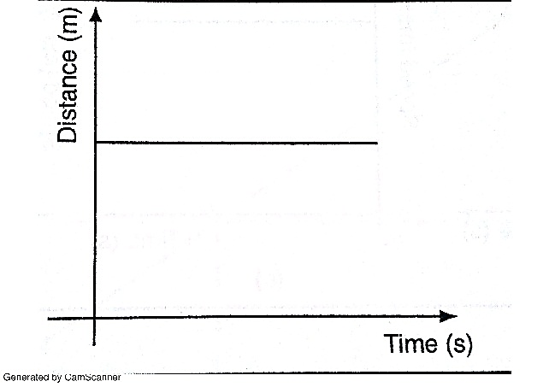

Stationary body

b)

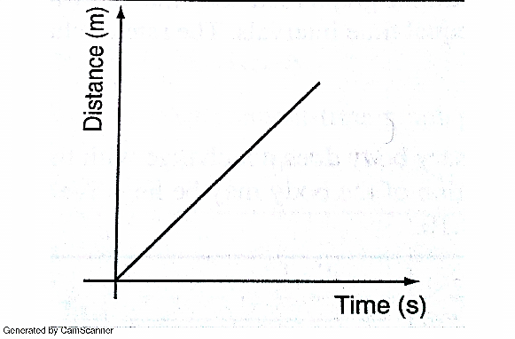

A body moving with uniform speed

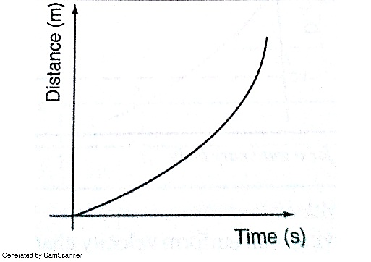
c)

A body moving with variable speed

Area under velocity-time graph
Consider a body with uniform or constant acceleration for time‘t’ seconds;

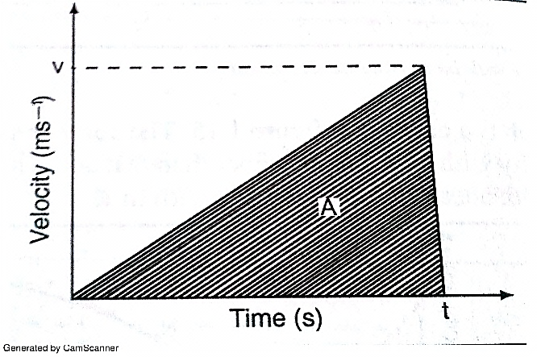

Distance travelled= average velocity*t
= (0+v/2)*t
=1/2vt
This is equivalent to the area under the graph. The area under velocity-time graph gives the distance covered by the body under‘t’ seconds.
Example
A car starts from rest and attains a velocity of 72km/h in 10 seconds. It travels at this velocity for 5 seconds and then decelerates to stop after another 6 seconds. Draw a velocity-time graph for this motion. From the graph;
- Calculate the total distance moved by the car
- Find the acceleration of the car at each stage.
Solution

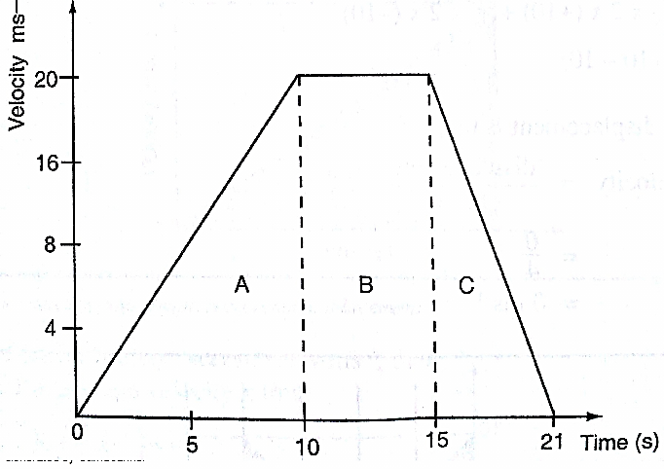

- From the graph, total distance covered= area of (A+B+C)
= (1/2×10×20) + (1/2×6×20) + (5×20)
=100+60+100
=260m
Also the area of the trapezium gives the same result.

- Acceleration= gradient of the graph
Stage A gradient= 20-0/ 10-0 = 2 m/s²
Stage b gradient= 20-20/15-10 =0 m/s²
Stage c gradient= 0-20/21-15 =-3.33 m/s²

Using a ticker-timer to measure speed, velocity and acceleration.
It will be noted that the dots pulled at different velocities will be as follows;

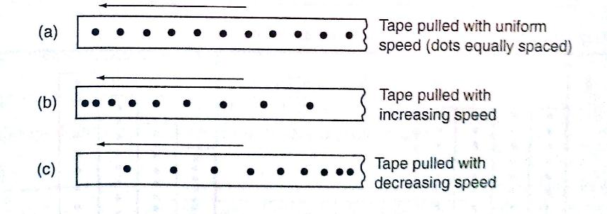
Most ticker-timers operate at a frequency of 50Hz i.e. 50 cycles per second hence they make 50 dots per second. Time interval between two consecutive dots is given as,
1/50 seconds= 0.02 seconds. This time is called a tick.
The distance is measured in ten-tick intervals hence time becomes 10×0.02= 0.2 seconds.
Examples
- A tape is pulled steadily through a ticker-timer of frequency 50 Hz. Given the outcome below, calculate the velocity with which the tape is pulled.

C
B
A

Solution
Distance between two consecutive dots= 5cm
Frequency of the ticker-timer=50Hz
Time taken between two consecutive dots=1/50=0.02 seconds
Therefore, velocity of tape=5/0.02= 250 cm/s
- The tape below was produced by a ticker-timer with a frequency of 100Hz. Find the acceleration of the object which was pulling the tape.

Solution
Time between successive dots=1/100=0.01 seconds
Initial velocity (u) 0.5/0.01 50 cm/s
Final velocity (v) 2.5/0.01= 250 cm/s
Time taken= 4 × 0.01 = 0.04 seconds
Therefore, acceleration= v-u/t= 250-50/0.04=5,000 cm/s²

Equations of linear motion
The following equations are applied for uniformly accelerated motion;
v = u + at
s = ut + ½ at²
v²= u² +2as
Examples
- A body moving with uniform acceleration of 10 m/s² covers a distance of 320 m. if its initial velocity was 60 m/s. Calculate its final velocity.
Solution
V² = u² +2as
= (60) +2×10×320
=3600+6400
= 10,000
Therefore v= (10,000)^{1/2}
v= 100m/s
- A body whose initial velocity is 30 m/s moves with a constant retardation of 3m/s. Calculate the time taken for the body to come to rest.
Solution
v = u + at
0= 30-3t
30=3t
t= 30 seconds.
- A body is uniformly accelerated from rest to a final velocity of 100m/s in 10 seconds. Calculate the distance covered.
Solution
s=ut + ½ at²
=0 × 10 + ½ ×10 × 10²
= 1000/2=500m

Motion under gravity.
- Free fall
The equations used for constant acceleration can be used to become,
v =u + g t
s =ut + ½ gt²
v²= u + 2gs
- Vertical projection
Since the body goes against force of gravity then the following equations hold
v =u- g t ……………1
s =ut - ½ gt² ……2
v²= u-2gs …………3
N.B time taken to reach maximum height is given by the following
t=u/g since v=0 (using equation 1)

Time of flight
The time taken by the projectile is the time taken to fall back to its point of projection. Using eq. 2 then, displacement =0
0= ut - ½ gt²
0=2ut-gt²
t (2u-gt)=0
Hence, t=0 or t= 2u/g
t=o corresponds to the start of projection
t=2u/g corresponds to the time of flight
The time of flight is twice the time taken to attain maximum height.

Maximum height reached.
Using equation 3 maximum height, H_{max} is attained when v=0 (final velocity). Hence
v²= u²-2gs;- 0=u²-2gH_{max}, therefore
2gH_{max}=u²
H_{max}=u²/2g

Velocity to return to point of projection.
At the instance of returning to the original point, total displacement equals to zero.
v² =u²-2gs hence v²= u²
Therefore v=u or v=±u
Example
A stone is projected vertically upwards with a velocity of 30m/s from the ground. Calculate,
- The time it takes to attain maximum height
- The time of flight
- The maximum height reached
- The velocity with which it lands on the ground. (take g=10m/s)
Solution
- Time taken to attain maximum height
T=u/g=30/10=3 seconds

- The time of flight
T=2t= 2×3=6 seconds
Or T=2u/g=2×30/10=6 seconds.

- Maximum height reached
H_{max}= u²/2g= 30×30/2×10= 45m

- Velocity of landing (return)
v²= u²-2gs, but s=0,
Hence v²=u²
Therefore v = (30×30)^{1/2}=30m/s
- Horizontal projection
The path followed by a body (projectile) is called trajectory. The maximum horizontal distance covered by the projectile is called range.

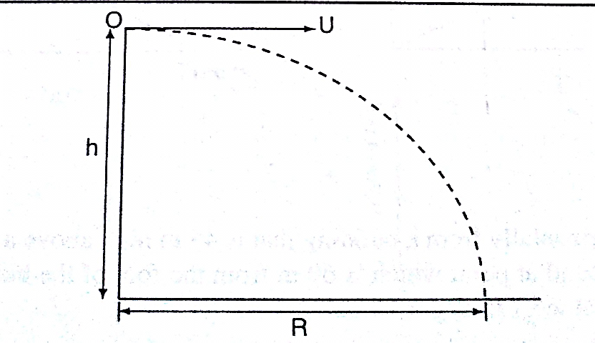

The horizontal displacement ‘R’ at a time‘t’ is given by s=ut+1/2at²
Taking u=u and a=0 hence R=u t, is the horizontal displacement and h=1/2gt² is the vertical displacement.
NOTE
The time of flight is the same as the time of free fall.

Example
A ball is thrown from the top of a cliff 20m high with a horizontal velocity of 10m/s. Calculate,
- The time taken by the ball to strike the ground
- The distance from the foot of the cliff to where the ball strikes the ground.
- The vertical velocity at the time it strikes the ground. (take g=10m/s)
Solution
- h= ½ gt²
20= ½ × 10 × t²
40=10t²
t²=40/10=4
t=2 seconds
- R=u t
=10×2
=20m
- v=u +a t=g t
= 2×10=20m/s
CHAPTER TWO
REFRACTION OF LIGHT

Introduction
Refraction is the change of direction of light rays as they pass at an angle from one medium to another of different optical densities.

Exp. To investigate the path of light through rectangular glass block.
Apparatus: - soft-board, white sheet of paper, drawing pins (optical), rectangular glass block.
Procedure
- Fix the white plain paper on the soft board using pins.
- Place the glass block on the paper and trace its outline, label it ABCD as shown below.
- Draw a normal NON at point O.
- Replace the glass block to its original position.
- Stick two pins P₁ and P₂ on the line such that they are at least 6cm apart and upright.
- Viewing pins P₁ and P₂ from opposite side, fix pins P₃ and P₄ such that they’re in a straight line.
- Remove the pins and the glass block.
- Draw a line joining P₃ and P₄ and produce it to meet the outline face AB at point O
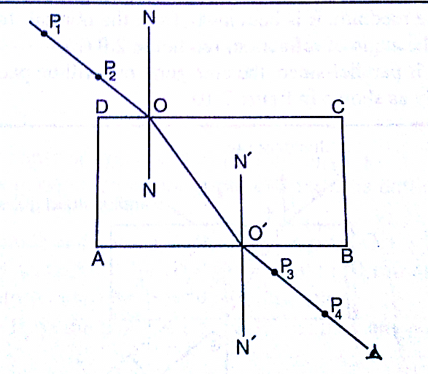

Explanation of refraction.
Light travels at a velocity of 3.0×10⁸ in a vacuum. Light travels with different velocities in different media. When a ray of light travels from an optically less dense media to more dense media, it is refracted towards the normal. The glass block experiment gives rise to a very important law known as the law of reversibility which states that “if a ray of light is reversed, it always travels along its original path”. If the glass block is parallel-sided, the emergent ray will be parallel to the incident ray but displaced laterally as shown
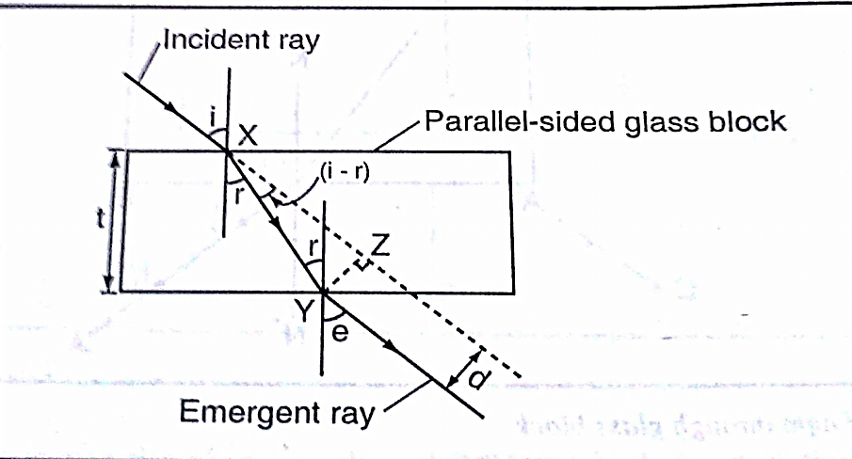

‘e’ is called the angle of emergence. The direction of the light is not altered but displaced sideways. This displacement is called lateral displacement and is denoted by‘d’. Therefore
XY= t/Cos r YZ= Sin (i - r) × x y
So, lateral displacement, d = t Sin (i - r)/Cos r
Laws of refraction
- The incident ray, the refracted ray and the normal at the point of incidence all lie on the same plane.
- The ratio of the sine of the angle of incidence to the sine of the angle of refraction is a constant for a given pair of media.
Sin i/sin r = constant (k)

Refractive index
Refractive index (n) is the constant of proportionality in Snell’s law; hence
Sin i/ sin r = n
Therefore sin i/sin r=n=1/sin r/sin i

Examples
- Calculate the refractive index for light travelling from glass to air given that _{a}n_{g}= 1.5
Solution
_{g}n_{a}= 1/_{a}n_{g} = 1/1.5=0.67

- Calculate the angle of refraction for a ray of light from air striking an air-glass interface, making an angle of 60⁰ with the interface. (_{a}n_{g} = 1.5)
Solution
Angle of incidence (i) = 90⁰- 60⁰=30⁰
1.5=sin 30º/sin r, sin r =sin 30⁰/ 1.5=0.5/1.5
Sin r=0.3333, sin⁻¹0.3333= 19.5⁰
R= 19.5⁰

Refractive index in terms of velocity.
Refractive index can be given in terms of velocity by the use of the following equation;

₁n₂ = velocity of light in medium 1/velocity of light in medium 2

When a ray of light is travelling from vacuum to a medium the refractive index is referred to as absolute refractive index of the medium denoted by ‘n’
Refractive index of a material ‘n’=velocity of light in a vacuum/velocity of light in material ‘n’
The absolute refractive indices of some common materials is given below
 | Material | Refractive index
1 | Air (ATP) | 1.00028
2 | Ice | 1.31
3 | Water | 1.33
4 | Ethanol | 1.36
5 | Kerosene | 1.44
6 | Glycerol | 1.47
7 | Perspex | 1.49
8 | Glass (crown) | 1.55
9 | Glass (flint) | 1.65
10 | Ruby | 1.76
11 | Diamond | 2.72

Examples
- A ray of light is incident on a water-glass interface as shown. Calculate ‘r’. (Take the refractive index of glass and water as 3/2 and 4/3 respectively)

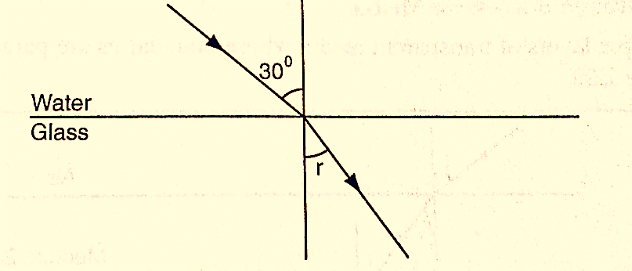

Solution
Since _{a}n_{w} sin θ_{w}=_{a}n_{g} sin_{g}
4/3 sin 30⁰= 3/2 sin r
3/2 sin r= 4/3× 0.5
Sin r =4/6×2/3=4/9= 0.4444
r = 26.4⁰
- The refractive index of water is 4/3 and that of glass is 3/2. Calculate the refractive index of glass with respect to water.
Solution
_{w}n_{g}= _{g}n_{a} × _{a}n_{g}, but _{w}n_{a} = 1/ _{a}n_{w}=3/4
_{w}n_{g}=3/4×3/2=9/8= 1.13

Real and apparent depth
Consider the following diagram
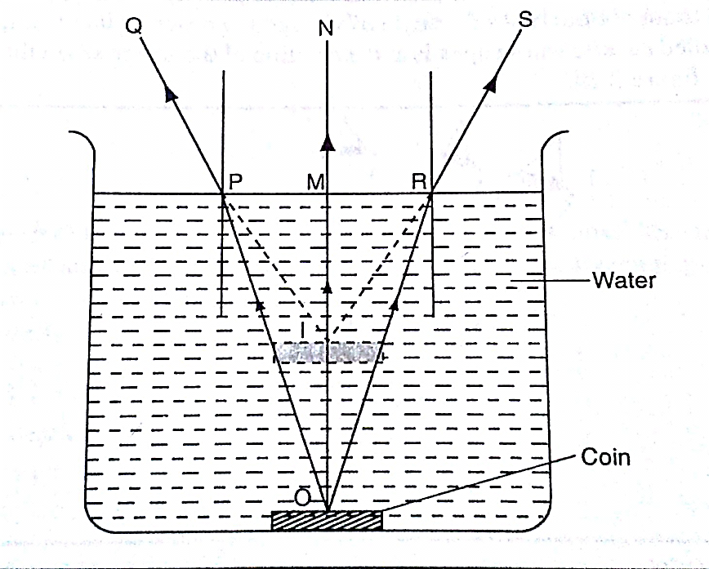

The depth of the water OM is the real depth, and the distance IM is known as the apparent depth. OI is the distance through which the coin has been displaced and is known as the vertical displacement. The relationship between refractive index and the apparent depth is given by;

Refractive index of a material=real depth/apparent depth
NB
This is true only if the object is viewed normally.
Example
A glass block of thickness 12 cm is placed on a mark drawn on a plain paper. The mark is viewed normally through the glass. Calculate the apparent depth of the mark and hence the vertical displacement. (Refractive index of glass =3/2)
Solution
_{a}n_{g}= real depth/apparent depth
apparent depth= real depth/ _{a}n_{g}=(12×2)/3= 8 cm
vertical displacement= 12-8=4 cm

Applications of refractive index
Total internal reflection
This occurs when light travels from a denser optical medium to a less dense medium. The refracted ray moves away from the normal until a critical angle is reached usually 90⁰ where the refracted ray is parallel to the boundary between the two media. If this critical angle is exceeded total internal reflection occurs and at this point no refraction occurs but the ray is reflected internally within the denser medium.
Relationship between the critical angle and refractive index.
Consider the following diagram
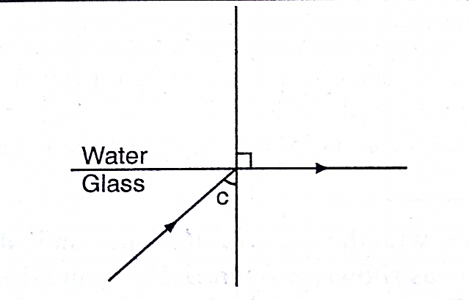

From Snell’s law
_{g}n_{w} = sin C/sin 90⁰,but _{a}n_{g} = 1/_{g}n_{a} since sin 90⁰ = 1
Therefore _{a}n_{g}= 1/sin C, hence sin C=1/n or n=1/sin C

Example
Calculate the critical angle of diamond given that its refractive index is 2.42
Solution
Sin C= 1/n=1/ 2.42= 0.4132= 24.4⁰

Effects of total internal reflection
- Mirage: These are ‘pools of water’ seen on a tarmac road during a hot day. They are also observed in very cold regions but the light curves in opposite direction such that a polar bear seems to be upside down in the sky.
- Atmospheric refraction: the earths’ atmosphere refracts light rays so that the sun can be seen even when it has set. Similarly the sun is seen before it actually rises.

Applications of total internal reflection
- Periscope: a prism periscope consists of two right angled glass prisms of angles 45⁰,90⁰ and 45⁰ arranged as shown below. They are used to observe distant objects.
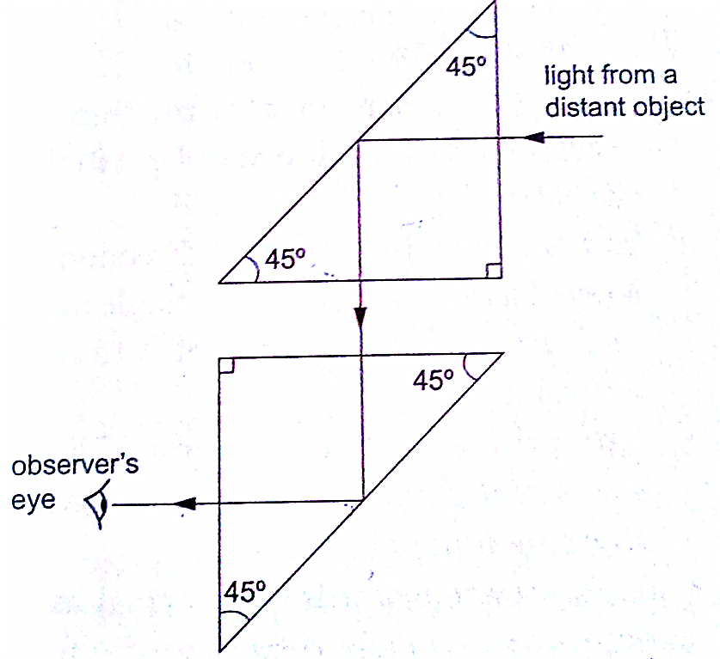

- Prism binoculars: the arrangement of lenses and prisms is as shown below. Binoculars reduce the distance of objects such that they seem to be nearer.

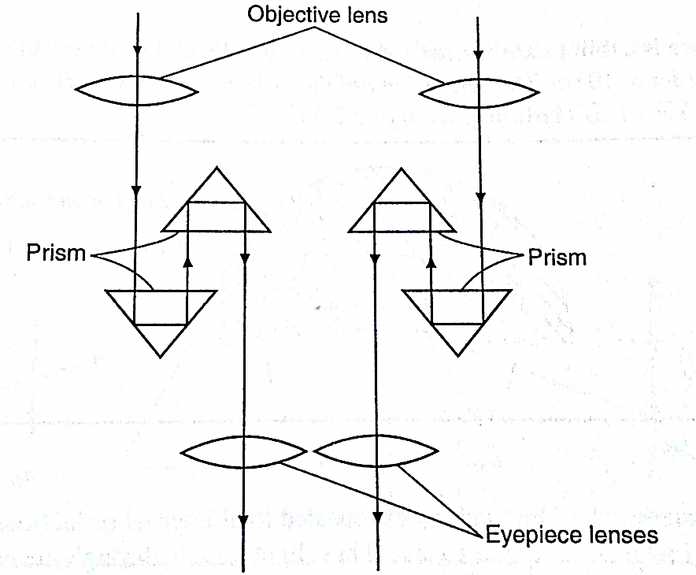

- Pentaprism: used in cameras to change the inverted images formed into erect and actual image in front of the photographer.
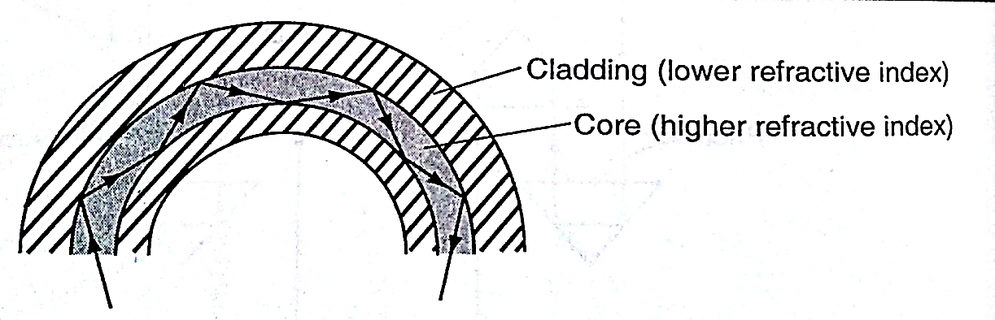
- Optical fibre: this is a flexible glass rod of small diameter. A light entering through them undergoes repeated internal reflections. They are used in medicine to observe or view internal organs of the body

- Dispersion of white light: the splitting of light into its constituent colours is known as dispersion. Each colour represents a different wavelength as they strike the prism and therefore refracted differently as shown.
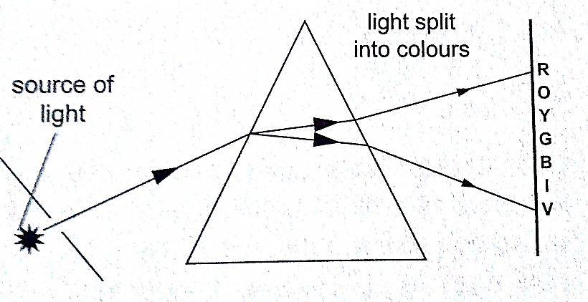

CHAPTER THREE
NEWTON’S LAWS OF MOTION
Newton’s first law (law of inertia)
This law states that “A body continues in its state of rest or uniform motion unless an unbalanced force acts on it”. The mass of a body is a measure of its inertia. Inertia is the property that keeps an object in its state of motion and resists any efforts to change it.
Newton’s second law (law of momentum)
Momentum of a body is defined as the product of its mass and its velocity.
Momentum ‘p’=mv. The SI unit for momentum is kgm/s or Ns. The Newton’s second law states that “The rate of change of momentum of a body is proportional to the applied force and takes place in the direction in which the force acts”
Change in momentum= mv-mu
Rate of change of momentum= mv-mu/∆t
Generally the second law gives rise to the equation of force F=ma
Hence F=mv-mu/∆t and F∆t=mv-mu
The quantity F∆t is called impulse and is equal to the change of momentum of the body. The SI unit for impulse is Ns.

Examples
- A van of mass 3 metric tons is travelling at a velocity of 72 km/h. Calculate the momentum of the vehicle.
Solution
Momentum=mv=72km/h = (20m/s) ×3×10³ kg
=6.0×10⁴ kgm/s

- A truck weighs 1.0×10⁵ N and is free to move. What force will give it an acceleration of 1.5 m/s²? (take g=10N/kg)
Solution
Mass of the truck = (1.0×10⁵)/10=6.0×10⁴
Using F=ma
=1.5×10×10⁴
=1.5×10⁴ N
- A car of mass 1,200 kg travelling at 45 m/s is brought to rest in 9 seconds. Calculate the average retardation of the car and the average force applied by the brakes.
Solution
Since the car comes to rest, v=0, a= (v-u)/t = (0-45)/9=-5m/s (retardation)
F=ma = (1200×-5) N =-6,000 N (braking force)
- A truck of mass 2,000 kg starts from rest on horizontal rails. Find the speed 3 seconds after starting if the tractive force by the engine is 1,000 N.
Solution
Impulse = Ft=1,000×3= 3,000 Ns
Let v be the velocity after 3 seconds. Since the truck was initially at rest then u=0.
Change in momentum=mv-mu
= (2,000×v) - (2,000×0)
=2,000 v
But impulse=change in momentum
2,000 v = 3,000
v = 3/2=1.5 m/s.

Weight of a body in a lift or elevator
When a body is in a lift at rest then the weight
W = mg
When the lift moves upwards with acceleration ‘a’ then the weight becomes
W = m (a + g)
If the lift moves downwards with acceleration ‘a’ then the weight becomes
W = m (g-a)
Example
A girl of mass stands inside a lift which is accelerated upwards at a rate of 2 m/s². Determine the reaction of the lift at the girls’ feet.
Solution
Let the reaction at the girls’ feet be ‘R’ and the weight ‘W’
The resultant force F= R-W
= (R-500) N
Using F = ma, then R-500= 50×2, R= 100+500 = 600 N.

Newton’s third law (law of interaction)
This law states that “For every action or force there is an equal and opposite force or reaction”
Example
A girl of mass 50 Kg stands on roller skates near a wall. She pushes herself against the wall with a force of 30N. If the ground is horizontal and the friction on the roller skates is negligible, determine her acceleration from the wall.
Solution
Action = reaction = 30 N
Force of acceleration from the wall = 30 N
F = ma
a = F/m = 30/50 = 0.6 m/s²

Linear collisions
Linear collision occurs when two bodies collide head-on and move along the same straight line. There are two types of collisions;
- Inelastic collision: - this occurs when two bodies collide and stick together i.e. hitting putty on a wall. Momentum is conserved.
- Elastic collision: - occurs when bodies collide and bounce off each other after collision. Both momentum and kinetic energy are conserved.

Collisions bring about a law derived from both Newton’s third law and conservation of momentum. This law is known as the law of conservation of linear momentum which states that “when no outside forces act on a system of moving objects, the total momentum of the system stays constant”.
Examples
- A bullet of mass 0.005 kg is fired from a gun of mass 0.5 kg. If the muzzle velocity of the bullet is 300 m/s, determine the recoil velocity of the gun.
Solution
Initial momentum of the bullet and the gun is zero since they are at rest.
Momentum of the bullet after firing = (0.005×350) = 1.75 kgm/s
But momentum before firing = momentum after firing hence
0 = 1.75 + 0.5 v where ‘v’ = recoil velocity
0.5 v = -1.75
v =-1.75/0.5 = - 3.5 m/s (recoil velocity)
- A resultant force of 12 N acts on a body of mass 2 kg for 10 seconds. What is the change in momentum of the body?
Solution
Change in momentum = ∆P = mv – mu= Ft
= 12×10 = 12 Ns
- A minibus of mass 1,500 kg travelling at a constant velocity of 72 km/h collides head-on with a stationary car of mass 900 kg. The impact takes 2 seconds before the two move together at a constant velocity for 20 seconds. Calculate
- The common velocity
- The distance moved after the impact
- The impulsive force
- The change in kinetic energy
Solution
- Let the common velocity be ‘v’
Momentum before collision = momentum after collision
(1500×20) + (900×0) = (1500 +900) v
30,000 = 2,400v
v = 30,000/2,400 = 12.5 m/s (common velocity)
- After impact, the two bodies move together as one with a velocity of 12.5 m/s
Distance = velocity × time
= 12.5× 20
= 250m
- Impulse = change in momentum
= 1500 (20-12.5) for minibus or
=900 (12.5 – 0) for the car
= 11,250 Ns
Impulse force F = impulse/time = 11,250/2 = 5,625 N
- K.E before collision = ½ × 1,500 × 20² = 3 × 10⁵ J
K.E after collision = ½ × 2400 × 12.5² = 1.875× 10⁵ J
Therefore, change in K.E = (3.00 – 1.875) × 10⁵ = 1.25× 10⁵ J

Some of the applications of the law of conservation of momentum
- Rocket and jet propulsion: - rocket propels itself forward by forcing out its exhaust gases. The hot gases are pushed through exhaust nozzle at high velocity therefore gaining momentum to move forward.
- The garden sprinkler: - as water passes through the nozzle at high pressure it forces the sprinkler to rotate.

Solid friction
Friction is a force which opposes or tends to oppose the relative motion of two surfaces in contact with each other.
Measuring frictional forces
We can relate weight of bodies in contact and the force between them. This relationship is called coefficient of friction. Coefficient of friction is defined as the ratio of the force needed to overcome friction F_{f} to the perpendicular force between the surfaces F_{n}. Hence
µ = F_{f} / F_{n}
Examples
- A box of mass 50 kg is dragged on a horizontal floor by means of a rope tied to its front. If the coefficient of kinetic friction between the floor and the box is 0.30, what is the force required to move the box at uniform speed?
Solution
F_{f} = µF_{n}
F_{n}= weight = 50×10 = 500 N
F_{f} = 0.30 × 500 = 150 N

- A block of metal with a mass of 20 kg requires a horizontal force of 50 N to pull it with uniform velocity along a horizontal surface. Calculate the coefficient of friction between the surface and the block. (take g = 10 m/s)
Solution
Since motion is uniform, the applied force is equal to the frictional force
F_{n} = normal reaction = weight = 20 ×10 = 200 N
Therefore, µ =F_{f} / F_{n} = 50/ 200 = 0.25.

Laws of friction
It is difficult to perform experiments involving friction and thus the following statements should therefore be taken merely as approximate descriptions: -
- Friction is always parallel to the contact surface and in the opposite direction to the force tending to produce or producing motion.
- Friction depends on the nature of the surfaces and materials in contact with each other.
- Sliding (kinetic) friction is less than static friction (friction before the body starts to slide).
- Kinetic friction is independent of speed.
- Friction is independent of the area of contact.
- Friction is proportional to the force pressing the two surfaces together.
Applications of friction
- Match stick
- Chewing food
- Brakes
- Motion of motor vehicles
- Walking
Methods of reducing friction
- Rollers
- Ball bearings in vehicles and machines
- Lubrication / oiling
- Air cushioning in hovercrafts

Example
A wooden box of mass 30 kg rests on a rough floor. The coefficient of friction between the floor and the box is 0.6. Calculate
- The force required to just move the box
- If a force of 200 N is applied the box with what acceleration will it move?
Solution
- Frictional force F_{f} = µF_{n} = µ(mg)
= 0.6×30×10 = 180 N
- The resultant force = 200 – 180 = 20 N
From F =ma, then 20 = 30 a
a = 20 / 30 = 0.67 m/s²

Viscosity
This is the internal friction of a fluid. Viscosity of a liquid decreases as temperature increases. When a body is released in a viscous fluid it accelerates at first then soon attains a steady velocity called terminal velocity. Terminal velocity is attained when F + U = mg where F is viscous force, U is upthrust and mg is weight.

CHAPTER FOUR
ENERGY, WORK, POWER AND MACHINES
Energy
This is the ability to do work.
Forms of energy.
- Chemical energy: - this is found in foods, oils charcoal firewood etc.
- Mechanical energy: - there are two types;
- Potential energy – a body possesses potential energy due to its relative position or state
- Kinetic energy – energy possessed by a body due to its motion i.e. wind, water
- Wave energy – wave energy may be produced by vibrating objects or particles i.e. light, sound or tidal waves.
- Electrical energy – this is energy formed by conversion of other forms of energy i.e. generators.
Transformation and conservation of energy
Any device that facilitates energy transformations is called transducer. Energy can be transformed from one form to another i.e. mechanical – electrical – heat energy. The law of conservation of energy states that “energy cannot be created or destroyed; it can only be transformed from one form to another”.

Work
Work is done when a force acts on a body and the body moves in the direction of the force.
Work done = force × distance moved by object
W = F × d
Work is measured in Nm. 1 Nm = 1 Joule (J)

Examples
- Calculate the work done by a stone mason lifting a stone of mass 15 kg through a height of 2.0 m. (take g=10N/kg)
Solution
Work done = force × distance
= (15× 10) × 2 = 300 Nm or 300 J
- A girl of mass 50 kg walks up a flight of 12 steps. If each step is 30 cm high, calculate the work done by the girl climbing the stairs.
Solution
Work done = force × distance
= (50× 10) × (12 ×30) ÷ 100 = 500 × 3.6 = 1,800 J
- A force of 7.5 N stretches a certain spring by 5 cm. How much work is done in stretching this spring by 8.0 cm?
Solution
A force of 7.5 produces an extension of 5.0 cm.
Hence 8.0 cm = (7.5 ×8)/ 5 = 12.0 N
Work done = ½ × force × extension
= ½ × 12.0 × 0.08 = 0.48 J
- A car travelling at a speed of 72 km/h is uniformly retarded by an application of brakes and comes to rest after 8 seconds. If the car with its occupants has a mass of 1,250 kg. Calculate;
- The breaking force
- The work done in bringing it to rest
Solution
- F = ma and a = v – u/t
But 72 km/h = 20m/s
a = 0 -20/8 = - 2.5 m/s
Retardation = 2.5 m/s
Braking force F = 1,250 × 2.5
= 3,125 N
- Work done = kinetic energy lost by the car
= ½ mv² – ½ mu²
= ½ × 1250 × 0² – ½ × 1250 × 20²
= - 2.5 × 10⁵ J
- A spring constant k = 100 Nm is stretched to a distance of 20 cm. calculate the work done by the spring.
Solution
Work = ½ ks²
= ½ × 100 × 0.2²
= 2 J
Power
Power is the time rate of doing work or the rate of energy conversion.
Power (P) = work done / time
P = W / t
The SI unit for power is the watt (W) or joules per second (J/s).
Examples
- A person weighing 500 N takes 4 seconds to climb upstairs to a height of 3.0 m. what is the average power in climbing up the height?
Solution
Power = work done / time = (force × distance) / time
= (500 ×3) / 4 = 375 W
- A box of mass 500 kg is dragged along a level ground at a speed of 12 m/s. If the force of friction between the box and floor is 1200 N. Calculate the power developed.
Solution
Power = F v
= 2,000 × 12
= 24,000 W = 24 kW.
Machines
A machine is any device that uses a force applied at one point to overcome a force at another point. Force applied is called the effort while the resisting force overcome is called load. Machines makes work easier or convenient to be done. Three quantities dealing with machines are;-
- Mechanical advantage (M.A.) - this is defined as the ratio of the load (L) to the effort (E). It has no units.
M.A = load (L) / effort (E)
- Velocity ratio – this is the ratio of the distance moved by the effort to the distance moved by the load
V.R = distance moved by effort/ distance moved by the load
c) Efficiency – is obtained by dividing the work output by the work input and the getting percentage
Efficiency = (work output/work input) × 100
= (M.A / V.R) × 100
= (work done on load / work done on effort) × 100
Examples
- A machine; the load moves 2 m when the effort moves 8 m. If an effort of 20 N is used to raise a load of 60 N, what is the efficiency of the machine?
Solution
Efficiency = (M.A / V.R) × 100 M.A = load/effort =60/20 = 3
V.R =D_{E}/ D_{L} = 8/2 = 4
Efficiency = ¾ × 100 = 75%
Some simple machines
- Levers – this is a simple machine whose operation relies on the principle of moments
- Pulleys – this is a wheel with a grooved rim used for lifting heavy loads to high levels. The can be used as a single fixed pulley, or as a block-and-tackle system.
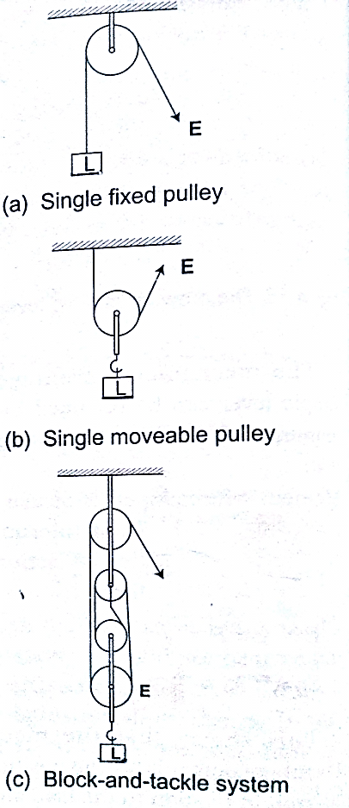

M.A = Load/ Effort
V.R = no. of pulleys/ no. of strings supporting the load
Example
A block and tackle system has 3 pulleys in the upper fixed block and two in the lower moveable block. What load can be lifted by an effort of 200 N if the efficiency of the machine is 60%?
Solution
V.R = total number of pulleys = 5
Efficiency = (M.A /V.R) × 100 = 60%
0.6 = M.A/ 5 =3, but M.A = Load/Effort
Therefore, load = 3 ×200 = 600 N
- Wheel and axle – consists of a large wheel of big radius attached to an axle of smaller radius.
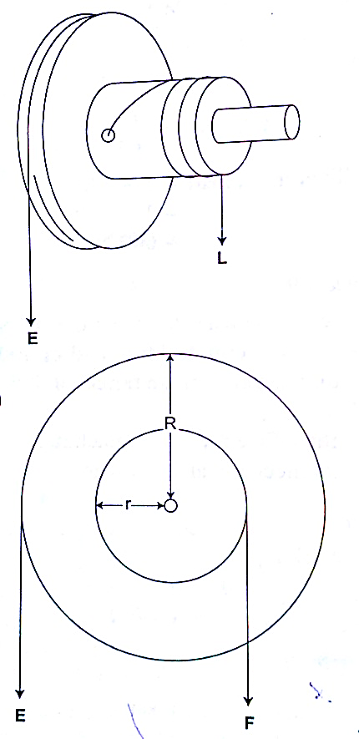

V.R = R/r and M.A = R/r
Example
A wheel and axle is used to raise a load of 280 N by a force of 40 N applied to the rim of the wheel. If the radii of the wheel and axle are 70 cm and 5 cm respectively. Calculate the M.A, V.R and efficiency.
Solution
M.A = 280 / 40 = 7
V.R = R/r = 70/5 = 14
Efficiency = (M.A/ V.R) × 100 = 7/14 × 100 = 50 %
- Inclined plane: -
V.R = 1/ sin θ M.A = Load/ Effort

Example
A man uses an inclined plane to lift a 50 kg load through a vertical height of 4.0 m. the inclined plane makes an angle of 30⁰ with the horizontal. If the efficiency of the inclined plane is 72%, calculate;
- The effort needed to move the load up the inclined plane at a constant velocity.
- The work done against friction in raising the load through the height of 4.0 m. (take g= 10 N/kg)
Solution
- V.R = 1 / sin C = 1/ sin 30⁰ = 2 M.A = efficiency × V.R = (72/100)× 2 = 1.44
Effort = load (mg) / effort (50×10)/ 1.44 = 347.2 N

- Work done against friction = work input – work output
Work output = m g h = 50×10×4 = 2,000 J
Work input = effort × distance moved by effort
347.2 × (4× sin 30⁰) = 2,777.6 J
Therefore work done against friction = 2,777.6 – 2,000 = 777.6 J
- The screw: - the distance between two successive threads is called the pitch
V.R of screw = circumference of screw head / pitch P
= 2πr / P
Example
A car weighing 1,600 kg is lifted with a jack-screw of 11 mm pitch. If the handle is 28 cm from the screw, find the force applied.
Solution
Neglecting friction M.A = V.R
V.R = 2πr /P = M.A = L / E
1,600 / E = (2π × 0.28) / 0.011
E = (1,600 × 0.011 × 7) / 22×2×0.28 =10 N
- Gears: - the wheel in which effort is applied is called the driver while the load wheel is the driven wheel.
V.R = revolutions of driver wheel / revolutions of driven wheel
Or
V.R = no. of teeth in the driven wheel/ no. of teeth in the driving wheel
Example

- Pulley belts: -these are used in bicycles and other industrial machines
V.R = radius of the driven pulley / radius of the driving pulley

- Hydraulic machines
V.R = R² / r² where R- radius of the load piston and r- radius of the effort piston
Example
The radius of the effort piston of a hydraulic lift is 1.4 cm while that of the load piston is 7.0 cm. This machine is used to raise a load of 120 kg at a constant velocity through a height of 2.5 cm. given that the machine is 80% efficient, calculate;
- The effort needed
- The energy wasted using the machine
Solution
- V.R = R² / r² = (7×7) / 1.4 × 1.4 = 25
Efficiency = M.A / V.R = (80 /100) × 25 = 20
But M.A = Load / Effort = (120×10) / 20 = 60 N
- Efficiency = work output / work input = work done on load (m g h) /80
= (120 × 10× 2.5) / work input
80 / 100 = 3,000 / work input
Work input = (3,000 × 100) /80 = 3,750 J
Energy wasted = work input – work output
= 3,750 – 3,000 = 750 J

CHAPTER FIVE
CURRENT ELECTRICITY
Electric potential difference and electric current
Electric current
Electric potential difference (p. d) is defined as the work done per unit charge in moving charge from one point to another. It is measured in volts.
Electric current is the rate of flow of charge. P. d is measured using a voltmeter while current is measured using an ammeter. The SI units for charge is amperes (A).

Ammeters and voltmeters
In a circuit an ammeter is always connected in series with the battery while a voltmeter is always connected parallel to the device whose voltage is being measured.

Ohm’s law
This law gives the relationship between the voltage across a conductor and the current flowing through it. Ohm’s law states that “the current flowing through a metal conductor is directly proportional to the potential difference across the ends of the wire provided that temperature and other physical conditions remain constant”
Mathematically V α I
So V /I = constant, this constant of proportionality is called resistance
V / I = Resistance (R)
Resistance is measured in ohms and given the symbol Ω

Examples
- A current of 2mA flows through a conductor of resistance 2 kΩ. Calculate the voltage across the conductor.
Solution
V = IR = (2 × 10⁻³) × (2 × 10³) = 4 V.

- A wire of resistance 20Ω is connected across a battery of 5 V. What current is flowing in the circuit?
Solution
I = V/R = 5 / 20 = 0.25 A
Ohmic and non-ohmic conductors
Ohmic conductors are those that obey Ohms law (V α I) and a good example is nichrome wire i.e. the nichrome wire is not affected by temperature.
Non-ohmic conductors do not obey Ohms law i.e. bulb filament (tungsten), thermistor couple, semi-conductor diode etc. They are affected by temperature hence non-linear.

Factors affecting the resistance of a metallic conductor
- Temperature – resistance increases with increase in temperature
- Length of the conductor – increase in length increases resistance
- Cross-sectional area – resistance is inversely proportional to the cross-sectional area of a conductor of the same material.
Resistivity of a material is numerically equal to the resistance of a material of unit length and unit cross-sectional area. It is symbolized by ρ and the units are ohmmeter (Ωm). It is given by the following formula;
ρ = AR /l where A – cross-sectional area, R – resistance, l – length
Example
Given that the resistivity of nichrome is 1.1× 10⁻⁶ Ωm, what length of nichrome wire of diameter 0.42 mm is needed to make a resistance of 20 Ω?
Solution
ρ = AR /l, hence l = RA/ ρ = 20 × 3.142 × (2.1×10⁻⁴) / 1.1 × 10⁻⁶ = 2.52 m

Resistors

Resistors are used to regulate or control the magnitude of current and voltage in a circuit according to Ohms law.
Types of resistors
- Fixed resistors – they are wire-wound or carbon resistors and are designed to give a fixed resistance.
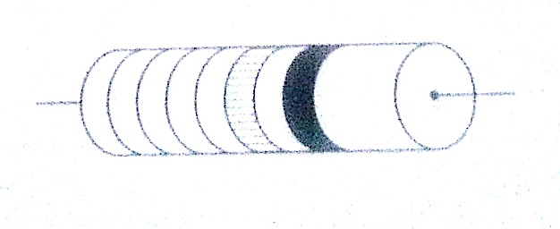
Carbon resistor

ii) Variable resistors – they consist of the rheostat and potentiometer. The resistance can be varied by sliding a metal contact to generate desirable resistance.

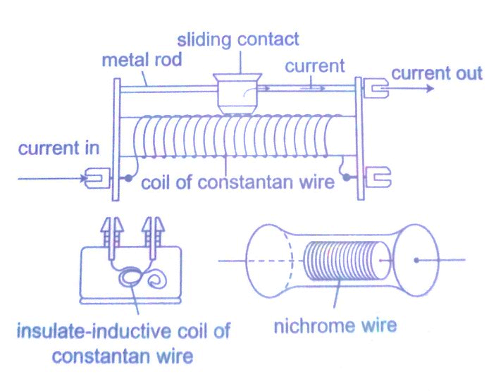

Wire-wound resistor

Resistor combination
- Series combination
Consider the following loop

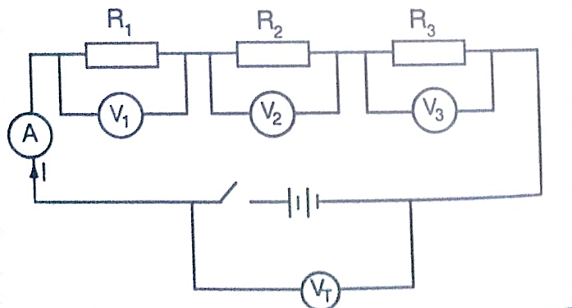

Since it is in series then,
V_{T} = V₁ + V₂ + V₃
The same current (I) flows through the circuit (resistors), hence
IR_{T} = I (R₁ + R₂ + R₃), dividing through by I, then
R_{T} = R₁ + R₂ + R₃
Therefore for resistors connected in series the equivalent resistance (R_{eq}) is equal to the total sum of their individual resistances.
R_{eq} = R₁ + R₂ + R₃

- Parallel combination
Consider the following circuit

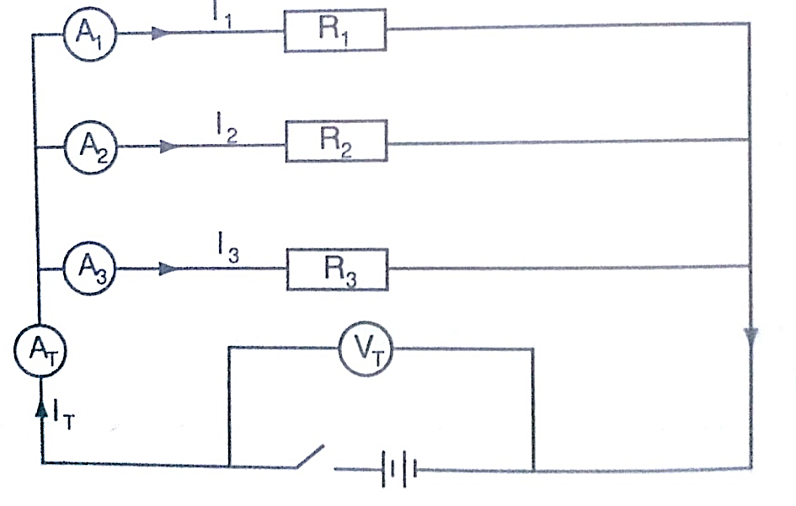

Total current is given by;
I_{T} = I₁ + I₂ + I_{3.} But I_{T} = V_{T}/R_{T} = V₁/R₁ + V₂/R₂ + V₃/R₃
Since in parallel, V_{T} = V₁ = V₂ = V₃
Then 1/R_{T} = 1/R₁ + 1/R₂ +1/R₃, for ‘n’ resistors in parallel
1/R_{T} = 1/R₁ + 1/R₂ +1/R₃ ………… 1/R _{n}
If only two resistors are involved then the equivalent resistance becomes
1/R_{eq} = 1/R₁ + 1/R₂ = (R₁ + R₂)/ R₁ R₂

Examples
- Calculate the effective resistance in the following
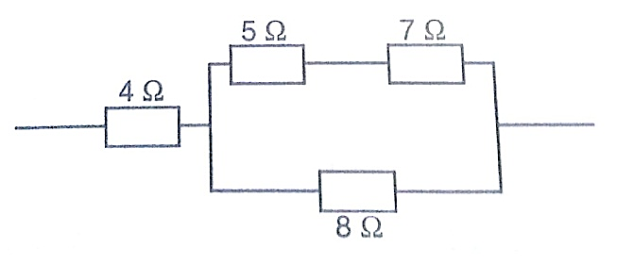

Solution
This reduces to
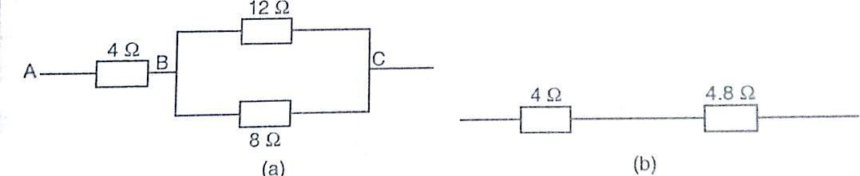

Combining the two in parallel;
1/R_{eq} = (R₁ + R₂)/R₁ R₂ = 20/96
1/R_{eq} = 20/96, therefore R_{eq} = 96/20 = 4.8 Ω
Lastly combining the two in series;
Then R_{eq} = 4 Ω + 4.8 Ω = 8.8 Ω
- In the diagram below, a current of 0.8 A, passing through an arrangement of resistors as shown below. Find the current through the 10 Ω resistor.

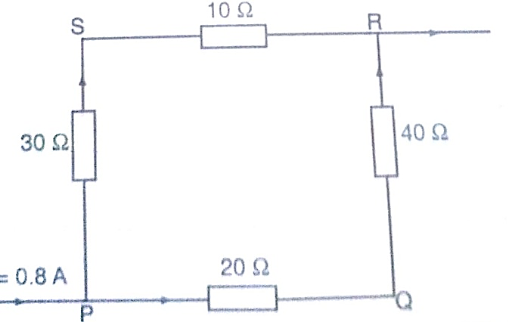

Solution
Combining those in series then this can be replaced by two resistors of 60 Ω and 40 Ω.
Current through 10 Ω = (p.d. between P and R)/ (30 + 10) Ω
p.d between P and R = 0.8 × R_{eq}. R_{eq} = (40 × 60)/ 40 + 60 = 2400/ 100 = 24 Ω
p.d across R and P = 0.8 × 24 (V=IR)
therefore, current through 10 Ω = 19.2 / 10 + 30 = 0.48 A

Electromotive force and internal resistance
Electromotive force (e.m.f.) is the p.d across a cell when no current is being drawn from the cell. The p.d across the cell when the circuit is closed is referred to as the terminal voltage of the cell. Internal resistance of a cell is therefore the resistance of flow of current that they generate. Consider the following diagram;
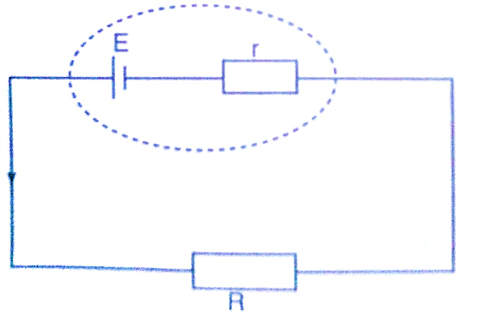

The current flowing through the circuit is given by the equation,
Current = e.m.f / total resistance
I = E / R + r where E – e.m.f of the cell
Therefore E = I (R + r) = IR + I r = V + I r
Examples
- A cell drives a current of 0.6 A through a resistance of 2 Ω. if the value of resistance is increased to 7 Ω the current becomes 0.2 A. calculate the value of e.m.f of the cell and its internal resistance.
Solution
Let the internal resistance be ‘r’ and e.m.f be ‘E’.
Using E = V + I r = IR + I r
Substitute for the two sets of values for I and R
E = 0.6 × (2 + 0.6 r) = 1.2 + 0.36 r
E = 0.6 × (7 × 0.2 r) = 1.4 + 0.12 r
Solving the two simultaneously, we have,
E = 1.5 v and R = 0.5 Ω
- A battery consists of two identical cells, each of e.m.f 1.5 v and internal resistance of 0.6 Ω, connected in parallel. Calculate the current the battery drives through a 0.7 Ω resistor.
Solution
When two identical cells are connected in series, the equivalent e.m.f is equal to that of only one cell. The equivalent internal resistance is equal to that of two such resistance connected in parallel. Hence R_{eq} = R₁ R₂ / R₁ + R₂ = (0.6 × 0.6) / 0.6 + 0.6 = 0.36 / 1.2 = 0.3 Ω
Equivalent e.m.f =1.5 / (0.7 + 0.3) = 1.5 A
Hence current flowing through 0.7 Ω resistor is 1.5 A

